SEC Form 4

FORM 4

Check this box if no longer subject to Section 16. Form 4 or Form 5 obligations may continue. See Instruction 1(b).

Check this box to indicate that a transaction was made pursuant to a contract, instruction or written plan for the purchase or sale of equity securities of the issuer that is intended to satisfy the affirmative defense conditions of Rule 10b5-1(c). See Instruction 10.

UNITED STATES SECURITIES AND EXCHANGE COMMISSION
Washington, D.C. 20549
Washington, D.C. 20549 |  | OMB APPROVAL
STATEMENT OF CHANGES IN BENEFICIAL OWNERSHIP
STATEMENT OF CHANGES IN BENEFICIAL OWNERSHIP |  | OMB Number: | 3235-0287
 |  | Estimated average burden
Filed pursuant to Section 16(a) of the Securities Exchange Act of 1934 |  | hours per response: | 0.5
or Section 30(h) of the Investment Company Act of 1940
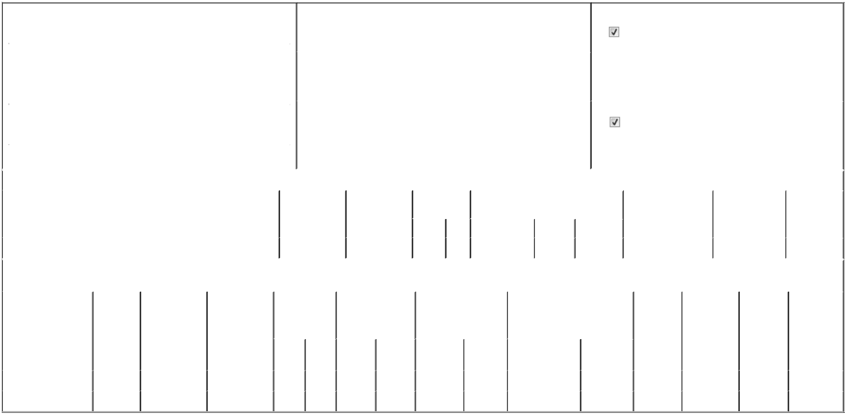

 | 1. Name and Address of Reporting Person* |  |  |  |  |  |  |  |  | 2. Issuer Name and Ticker or Trading Symbol |  |  |  |  |  |  |  |  |  | 5. Relationship of Reporting Person(s) to Issuer
 |  | Hager Mary M. |  |  |  |  |  |  |  | Piedmont Realty Trust, Inc. [ PDM ] |  |  |  |  |  |  |  |  |  | (Check all applicable)
 |  | Hager Mary M. |  |  |  |  |  |  |  |  |  |  |  |  |  |  |  |  |  |  |  | Director |  |  | 10% Owner
 |  |  |  |  |  |  |  |  |  |  |  |  |  |  |  |  |  |  |  |  |  | Officer (give title |  |  | Other (specify below)
 |  | (Last) |  | (First) |  | (Middle) |  |  |  |  |  |  |  |  |  |  |  |  |  |  |  | below)
 |  |  |  | (First) |  | (Middle) |  |  |  | 3. Date of Earliest Transaction (Month/Day/Year) |  |  |  |  |  |  |  |  |  |  |  | below)
 |  | 5565 GLENRIDGE CONNECTOR |  |  |  |  | 05/12/2026
 |  | STE. 450
 |  |  |  |  |  |  |  |  |  | 4. If Amendment, Date of Original Filed (Month/Day/Year) |  |  |  |  |  |  |  |  |  | 6. Individual or Joint/Group Filing (Check Applicable Line)
 | (Street)
 |  |  |  |  |  |  |  |  |  |  |  |  |  |  |  |  |  |  |  |  |  | Form filed by One Reporting Person
 |  | ATLANTA |  | GA |  | 30342
 |  |  |  | GA |  | 30342 |  |  |  |  |  |  |  |  |  |  |  |  |  |  |  | Form filed by More than One Reporting Person
 |  | (City) |  | (State) |  | (Zip)
 |  |  |  |  |  | Table I - Non-Derivative Securities Acquired, Disposed of, or Beneficially Owned
 | 1. Title of Security (Instr. 3) |  |  |  |  |  | 2. Transaction |  |  |  | 2A. Deemed |  | 3. Transaction |  |  | 4. Securities Acquired (A) or Disposed Of |  |  |  |  | 5. Amount of Securities |  |  | 6. Ownership |  | 7. Nature of
 |  |  |  |  |  |  | Date |  |  |  | Execution Date, |  | Code (Instr. 8) (D) (Instr. 3, 4 and 5) |  |  |  |  |  |  |  | Beneficially Owned |  |  | Form: Direct (D) or |  | Indirect
 |  |  |  |  |  |  | (Month/Day/Year) if any |  |  |  |  |  |  |  |  |  |  |  |  |  | Following Reported |  |  | Indirect (I) (Instr. 4) |  | Beneficial
 |  |  |  |  |  |  |  |  |  |  | (Month/Day/Year) |  | Code |  | V | Amount |  | (A) or (D) | Price |  | Transaction(s) (Instr. 3 |  |  |  |  | Ownership
 |  |  |  |  |  |  |  |  |  |  |  |  | Code |  | V | Amount |  | (A) or (D) |  |  | and 4) |  |  |  |  | (Instr. 4)
 | Common Stock |  |  |  |  |  | 05/12/2026 |  |  |  |  |  | M |  |  | 15,217 |  | A | (1)(2) |  | 49,190 |  |  |  | D
 |  |  |  |  |  | Table II - Derivative Securities Acquired, Disposed of, or Beneficially Owned
 |  |  |  |  |  |  | (e.g., puts, calls, warrants, options, convertible securities)
 | 1. Title of Derivative |  |  | 2. | 3. Transaction | 3A. Deemed | 4. Transaction |  |  |  | 5. Number of |  | 6. Date Exercisable and |  |  |  | 7. Title and Amount of Securities |  |  |  |  | 8. Price of | 9. Number of |  | 10. | 11. Nature of
 | Security (Instr. 3) |  |  | Conversion | Date | Execution Date, | Code (Instr. 8) |  |  |  | Derivative Securities |  | Expiration Date |  |  |  | Underlying Derivative Security |  |  |  |  | Derivative | derivative |  | Ownership | Indirect
 |  |  |  | or Exercise | (Month/Day/Year) if any |  |  |  |  |  | Acquired (A) or |  | (Month/Day/Year) |  |  |  | (Instr. 3 and 4) |  |  |  |  | Security | Securities |  | Form: | Beneficial
 |  |  |  | Price of |  | (Month/Day/Year) |  |  |  |  | Disposed of (D) |  |  |  |  |  |  |  |  |  |  | (Instr. 5) | Beneficially |  | Direct (D) or | Ownership
 |  |  |  | Derivative |  |  |  |  |  |  | (Instr. 3, 4 and 5) |  |  |  |  |  |  |  |  |  |  |  | Owned |  | Indirect (I) | (Instr. 4)
 |  |  |  | Security |  |  |  |  |  |  |  |  |  |  |  |  |  |  |  |  |  |  | Following |  | (Instr. 4)
 |  |  |  |  |  |  |  |  |  |  |  |  |  |  |  |  |  |  | Amount or |  |  |  | Reported
 |  |  |  |  |  |  |  |  |  |  |  |  | Date |  |  | Expiration |  |  | Number of |  |  |  | Transaction(s)
 |  |  |  |  |  |  | Code V |  |  |  | (A) | (D) | Exercisable |  |  | Date | Title |  | Shares |  |  |  | (Instr. 4)
 | Restricted Stock Units |  |  | _{$0}(2) | 05/12/2026 |  | M |  |  |  |  | 15,217 |  | (1) |  | (1) |  | Common Stock | 15,217 |  | $0 |  | 0 |  | D
 | Restricted Stock Units |  |  | _{$0}(2) | 05/12/2026 |  | A |  |  |  | 12,883 |  |  | (3) |  | (3) |  | Common Stock | 12,883 |  | $0 |  | 12,883 |  | D

Explanation of Responses:

- On May 15, 2025, at the 2025 Annual Meeting of Stockholders of Piedmont Realty Trust, Inc., the reporting person was granted 15,217 restricted stock units, which vested at the 2026 Annual Meeting of Stockholders on May 12, 2026, and was settled in PDM common stock.

- Each restricted stock unit represents a contingent right to receive one share of PDM common stock. Restricted stock units may be settled in cash or common stock at PDM's election.

- On May 12, 2026, at the 2026 Annual Meeting of Stockholders of Piedmont Realty Trust, Inc., the reporting person was granted 12,883 restricted stock units, which will vest on the earlier of the 2027 Annual Meeting of Stockholders, or the anniversary of the grant date in May 2027.

Remarks:

/s/ M. Wade Grace III, as Attorney-in-

Fact for Mary M. Hager

** Signature of Reporting Person

05/13/2026

Date

Reminder: Report on a separate line for each class of securities beneficially owned directly or indirectly.

* If the form is filed by more than one reporting person, see Instruction 4 (b)(v).

- Intentional misstatements or omissions of facts constitute Federal Criminal Violations See 18 U.S.C. 1001 and 15 U.S.C. 78ff(a). Note: File three copies of this Form, one of which must be manually signed. If space is insufficient, see Instruction 6 for procedure.
Persons who respond to the collection of information contained in this form are not required to respond unless the form displays a currently valid OMB Number.



